Community Better Together Challenge: Help Hamiota win $100,000

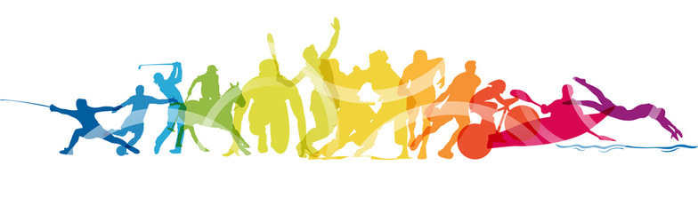
All physical activity can be counted, including:
Swimming
Biking
Walking
Hiking
Basketball
Volleyball
Horseback Riding
Yoga
Golfing
Soccer
Baseball
And more!
June 1 - 30, 2021
Let’s Get Active!!
This June, Hamiota will be participating in the ParticipACTION Community Better Challenge, the physical activity challenge that rallies communities to get moving. From June 1 – 30, let’s get active and be Canada’s Most Active Community and win $100,000 for local physical activity initiatives!
- Participate by downloading the (FREE) ParticipACTION app where you can track your activity and contribute to the challenge,
Or
- Fill in the form in your Leader with the Date, number of active minutes and your activity and drop the filled in forms off at the Municipal office before July 5!!!
Every move counts! #CommunityBetterChallenge

To help you get active, Recreation Hamiota has scheduled some community events throughout the month of June:
- Free Pickleball and Basketball at the rink June 7 – 13 (email to book a court)
- Organized Kid Sports and activities June 14 – 18 (limited spaces, email to register by June 5)
- Night Beach Volleyball June 25 (email to register your team by June 15th)
- Free Swimming at the Pool June 21 - 25
Email: recreation@hamiota.com
COVID Regulations will apply!

Date | Activity | Number of Minutes
Name:

